National Policy Forum (NPF) Submission
Realising the unique contribution of Britain’s £28bn international visitor sector to support Labour’s mission for our economy
Helping to create and support good growth, good jobs and good standards of living across the whole of the UK as global technological advances produce more wealth and more leisure time
OVERVIEW AND RECOMMENDATIONS
The importance of the UK’s visitor economy in achieving Labour’s economic mission
Britain is a world leader in attracting international visitors. In 2019 international visitors spent over £28bn of foreign money in the UK, equivalent to Britain’s fourth largest export sector, and supported nearly half a million jobs throughout the whole of the country.
Labour’s mission is to secure the highest sustained growth in the G7, growth that depends upon global standing. Labour will produce a proper long-term plan for growth to ensure that wages and living standards can rise and where wealth is created everywhere, by everyone, for everyone.
The development of technology will lead to a world where people have more wealth and more leisure time. To balance Britain’s high-tech economic development a Labour Government should recognise and encourage the importance, global standing and growth potential of Britain’s international visitor sector and its ability to create wealth everywhere, by everyone, for everyone.
Proposals for policy consideration
Recommendation One – A Labour Government should recognise the current and future importance of international visitor sector and Britain’s world leadership and the sector should be included as a central part of a balanced plan for long-term growth where wealth is created everywhere, by everyone, for everyone.
Recommendation Two – A Labour Government should create a structure within Government that gives the international visitor sector the prominence and influence that it deserves, linked to the domestic tourist sector. Tourism should move to the Business Department. The Tourism Minister should be at least a Minister of State and have responsibility for all connected sectors (hospitality, retail, tourism, culture). There should be a small inter-departmental tourism structure created to include (ministers and officials) from Business, Home Office and Treasury.
Recommendation Three – A Labour Government should undertake an independent assessment of the full impact of tax-free shopping on the UK economy and tax revenues and commit to restore the scheme if is shown to be cost free to the Government.
Recommendation Four – A Labour Government should add the two statutory International Centres as defined in the Mayor’s 2021 London Plan to the list of exemptions in the 1994 Sunday Trading Act.
Recommendation Five – A Labour Government should ensure that any British visitor visa is at least as attractive as its Schengen equivalent (duration, multiple entry, cost); should work to enable travellers wishing to apply for both a Schengen and UK visitor visa can do so easily and at the same time and place; and should move quickly to the Electronic Travel Authorisation (ETA) system, particularly in countries with high- spending travellers. ETA holders should be allowed to use E gates at UK airports.

Realising the unique contribution of Britain’s £28bn international visitor sector to support Labour’s mission for our economy
Part one – the importance of the UK’s visitor economy in achieving Labour’s economic mission
Labour’s Mission
Labour has a mission for Britain’s economy – to secure the highest sustained growth in the G7. This will see Britain leading on science, technology, green growth and the opportunities of tomorrow. Sir Keir has said he believes that “growth depends upon stability and standing – global standing” and he wants a “proper long-term plan for growth to ensure that wages and living standards can rise
He wants a new model for economic growth “where wealth is created everywhere, by everyone, for everyone”. He doesn’t “want a Britain where young people in our great towns and cities, are left with no options to get out.” Sir Keir says “what I want to see is raising living standards across the country. So in many places, the discussion in the local pub or cafe will not be about the strategic plan for growth, but it will be about my living standards. Our model of growth has to be growth everywhere. But it has to be laser focused on living standards.”
Science, technology, green growth and the opportunities of tomorrow are at the centre of long-term planning for growth. Continual technological advances are changing the way in which the world works. We are discovering, developing and moving from laboratory to workplace a wide range of practical uses for core high-technology advances at a pace that is becoming increasingly shorter and more immediate.
These will transform the way in which people across the world live their lives. More people will move out of poverty, more people will be fed, more people will receive healthcare, education, social care, housing. And new technologies are increasingly playing a major part in the will help to fight the global crisis of climate change and a range of wider negative impacts on the planet and the lives of people caused by traditional economic growth activity.
Helping Labour to achieve that mission – the bigger picture
As Sir Keir has shown, Britain is already in a strong position to lead and benefit from much of this technological development while at the same time helping the whole world to grow and evolve in ways which are sustainable and beneficial to everyone.
Our submission to the National Policy Forum develops this thinking to suggest that we need to look in parallel the wider implications of positive technological advances on people’s work and lifestyles and explore how we can also take a lead in those areas where we are already world leaders.
We fully support the Labour Party’s wish to ensure that the new economic era is one “where wealth is created everywhere, by everyone, for everyone”. The last time that the world saw a seismic change in the economic model, with the growth of the internet, much has led to the concentration of the economic benefits in an increasingly smaller number of people while most others get left behind.
Our submission seeks to avoid that as new technological developments globally leads to a world with greater wealth and more leisure time.
Wider implications
A long-term plan for an economy with a focus of leading high tech sectors requires two complementary elements. What is the plan for the majority of people not directly employed in these sectors to ensure they don’t get left behind? How do we make the most of the opportunities that will arise as these technological advances alter the way that people live and work?
In the first case, inevitably the focus on high tech industry will directly employ highly skilled people based in existing areas of technological research such as London, and our world beating universities particularly Oxford Cambridge. It is hard to see how the people and the regions outside these areas will directly befit from new jobs and associated wealth creation.
This is where the international visitor economy has a key role to play. With more leisure time and more wealth generally throughout the world, the international visitor economy will continue to grow. A number of governments have realised this potential and are planning accordingly. The Gulf States in particular are planning for an era when fossil fuels will no longer be in demand and are clearly restructuring their economies to focus more on the international visitor sector. This can be seen in the growth of high quality hotels and spectacular shopping malls; the establishment of satellites of globally renowned museums including the Louvre and the Hermitage; the attraction of global sporting events such as the World Cup, F1 Motor Racing, the World Tennis Championships, LIV Golf; the introduction of visitor visas and even relaxation of laws on such as allowing women to drive in Saudi Arabia, are all part of the coordinated move towards economies that are putting he international visitor sector at the heart of their future economic planning. And this is happening around the world in response to the seismic economic changes created by high tech development.
Britain’s opportunity as a world leader
Just as Britain is seeking to benefit from its leadership position in certain key high-tech industries with world beating assets such as our university and research facilities, so we should build on our leading position in the global visitor economy. In 2018 the UK was ranked eighth in the UNWTO international tourist arrivals, accounting for 2.7% of global arrivals and 11th place in the international tourism earnings league, accounting for 2.4% of international tourism receipts. In 2022, London was number six in the Top 100 City Destinations Index.
Already a top ten global destination, Britain has an world class mix of attractions based on traditional heritage, natural beauty and history but constantly evolving through internationally followed fashion, culture, music, sport, TV and film.
Shopping is another word beating attraction. London’s West End has over 250 European and UK flagship stores. Shopping is the number one attraction for Chinese visitors and with globally recognised names such as Selfridges and Harrods and international shopping destinations such as Oxford Street, Regent Street, Bond Street and Bicester Village.
The value and growth of the UK’s international visitor sector
In the ten years from 2009-2019 international visitor numbers to the UK grew from 31 million to 40.9 million (+32%) and spending grew from £17.6bn to £28.4bn (+61%). Much of this was driven by the global growth in the number and spending levels of Chinese visitors, now by far the highest spending international travellers and still with huge potential for growth.
Inbound tourism will continue to be the fastest growing tourism sector – with spend by international visitors forecast to grow by over 6% a year in comparison with domestic spending by UK residents at just over 3%. The value of inbound tourism is forecast to grow to £57bn by 2025 (note – this was a pre-COVID-19 forecast).
Most importantly, the money generated by international visitors is foreign money being brought into the UK to add to the British economy. If our sector was classified as an export sector by the ONS it would be one of the UK’s top performers. International visitors are just starting to return post COVID-19 but in 2019 they spent £28.4 bn in the UK on a mixture of goods (exported) and services (consumed but still paid for by foreign money). This would make the international visitor sector the third largest in terms of goods exported in 2022 behind unspecified goods (£33.8bn) and crude oil (£28.8bn) but ahead of all other goods such as medicinal and pharmaceutical (£25.4bn) and cars (£24.7bn). In terms of services exported, the sector is fourth behind other business services (£145bn), financial services (£72bn), and telecoms, computer and information services (£34bn) but ahead of other services such as intellectual property (£23bn) and insurance and pensions (£19bn).
All of the UK benefits
London is the main gateway to the UK for most international visitors but the international visitor economy is already a major part of the economic mix for almost every part of the UK. In 2019, London accounted for 55% of all inbound visitor spend, the rest of England 32%, Scotland 9% and Wales 2%. The distribution of tax-free shopping spending in 2019 is a useful guide. Edinburgh, Manchester, Liverpool, Glasgow and Leeds together accounted for £225 million tax-free sales.
Jobs for all
The international visitor economy directly creates and sustains around 452,000 jobs across the whole of the UK. These jobs are open to all and are in sectors such as hospitality, retail, tourism., leisure and culture which provide fast routes to progression.
Part two – Proposals for policy consideration
Recognise the sector’s strategic importance and a vital part of the long term economic plan for Britain
For too long, the international visitor sector has been either forgotten or taken for granted by successive governments. Its current value and future potential is not fully appreciated.
Recommendation One – A Labour Government should recognise the current and future importance of international visitor sector and Britain’s world leadership and the sector should be included as a central part of a balanced plan for long-term growth where wealth is created everywhere, by everyone, for everyone.

Enhance the standing of the international visitor sector within the hierarchy and machinery of Government
Tourism is currently an element of the DCMS. Previously it was part of what is now the Department of Business and Trade, the department where the sector’s key components lie – hospitality and retail. But the travel element falls within the Department of Transport. And issues that are vitally important to the sector’s vitality fall in other departments – visitor visas are the responsibility of the Home Office; tax-free shopping is a Treasury matter. Usually these larger departments put their core departmental priorities above those of international visitor sector. When the tourism minister gave evidence to a recent inquiry by the DCMS Select Committee inquiry on international visitors he was unable to provide details on many of the key issues raised by the committee, such as tax-free shopping.
This fragmentation of responsibility and priorities weakens the ability of the international tourism sector to work with government on policy developments which are key to the sector’s future growth.
Recommendation Two – A Labour Government should create a structure within Government that gives the international visitor sector the prominence and influence that it deserves, linked to the domestic tourist sector. Tourism should move to the Business Department. The Tourism Minister should be at least a Minister of State and have responsibility for all connected sectors (hospitality, retail, tourism, culture). There should be a small inter-departmental tourism structure created to include (ministers and officials) from Business, Home Office and Treasury.
Implement policies to secure the UK’s international competitiveness
There are currently three major policy issues that are holding-back Britain’s international visitor sector and making Britain uncompetitive in an increasingly competitive world.
Tax-free shopping – since January 2021 Britain has been the only major European country not to offer VAT refunds on exported goods purchased by international visitors. This has seen billions of pounds of spending and investment diverted from Britain to France, Spain and Italy. As Britain is no longer a member of the EU there is the opportunity to make the UK the shopping destination of Europe by offering VAT refunds to EU visitors, providing a massive boost to all parts of the UK. The Mayor of London has made the case for restoration of the scheme (see attached letter)
Recommendation Three – A Labour Government should undertake an independent assessment of the full impact of tax-free shopping on the UK economy and tax revenues and commit to restore the scheme if is shown to be cost free to the Government.
Sunday trading in the International Centres – the two statutory International Centres in London are at a competitive disadvantage compared with virtually every other global shopping district because they have to close at 6PM on Sundays. Exempting hem from Sunday trading regulations would generate a net £340m in additional sales each year and result in £70m additional VAT collected.
Recommendation Four – A Labour Government should add the two statutory International Centres as defined in the Mayor’s 2021 London Plan to the list of exemptions in the 1994 Sunday Trading Act
Welcoming visitors and removing unnecessary barriers – Because Britain is not a member of the Schengen Area, visitors to Europe from countries where visitor visas are required need to apply separately for the two visas needed to include the UK on a multi-country tour. This is burdensome and most visitors apply for only a Schengen visa which allows access to 26 European countries.
Recommendation Five – A Labour Government should ensure that any British visitor visa is at least as attractive as its Schengen equivalent (duration, multiple entry, cost); should work to enable travellers wishing to apply for both a Schengen and UK visitor visa can do so easily and at the same time and place; and should move quickly to the Electronic Travel Authorisation (ETA) system, particularly in countries with high- spending travellers. ETA holders should be allowed to use E gates at UK airports.

Paul Barnes
Chief Executive Association of international Retail
paul@internationalretail.co.uk
07969111619
www.internationalretail.co.uk

Appendix (Mayor of London’s Letter to the Chancellor)
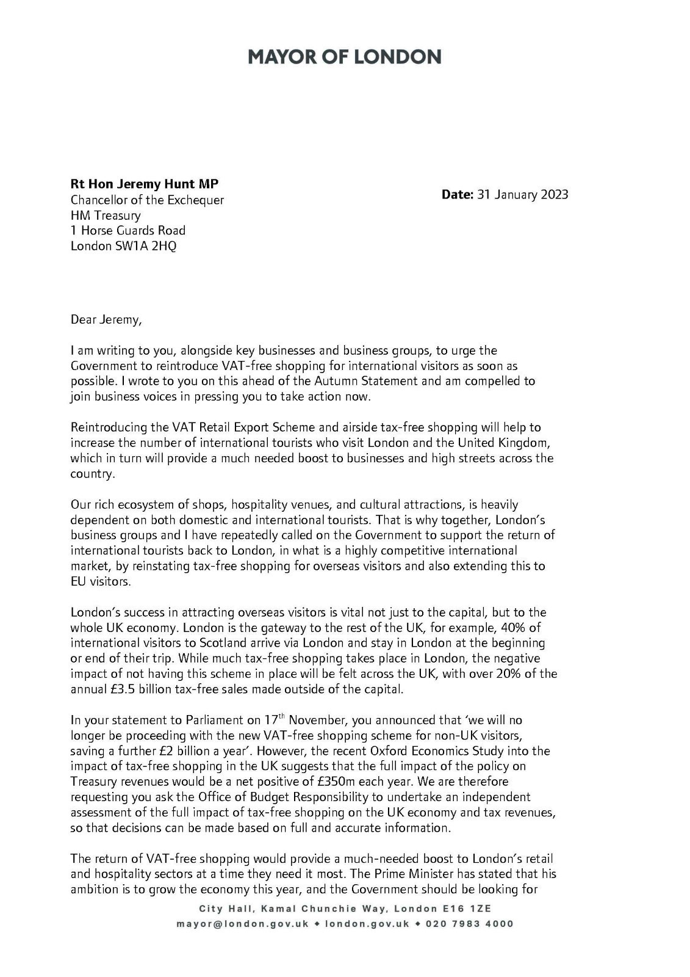
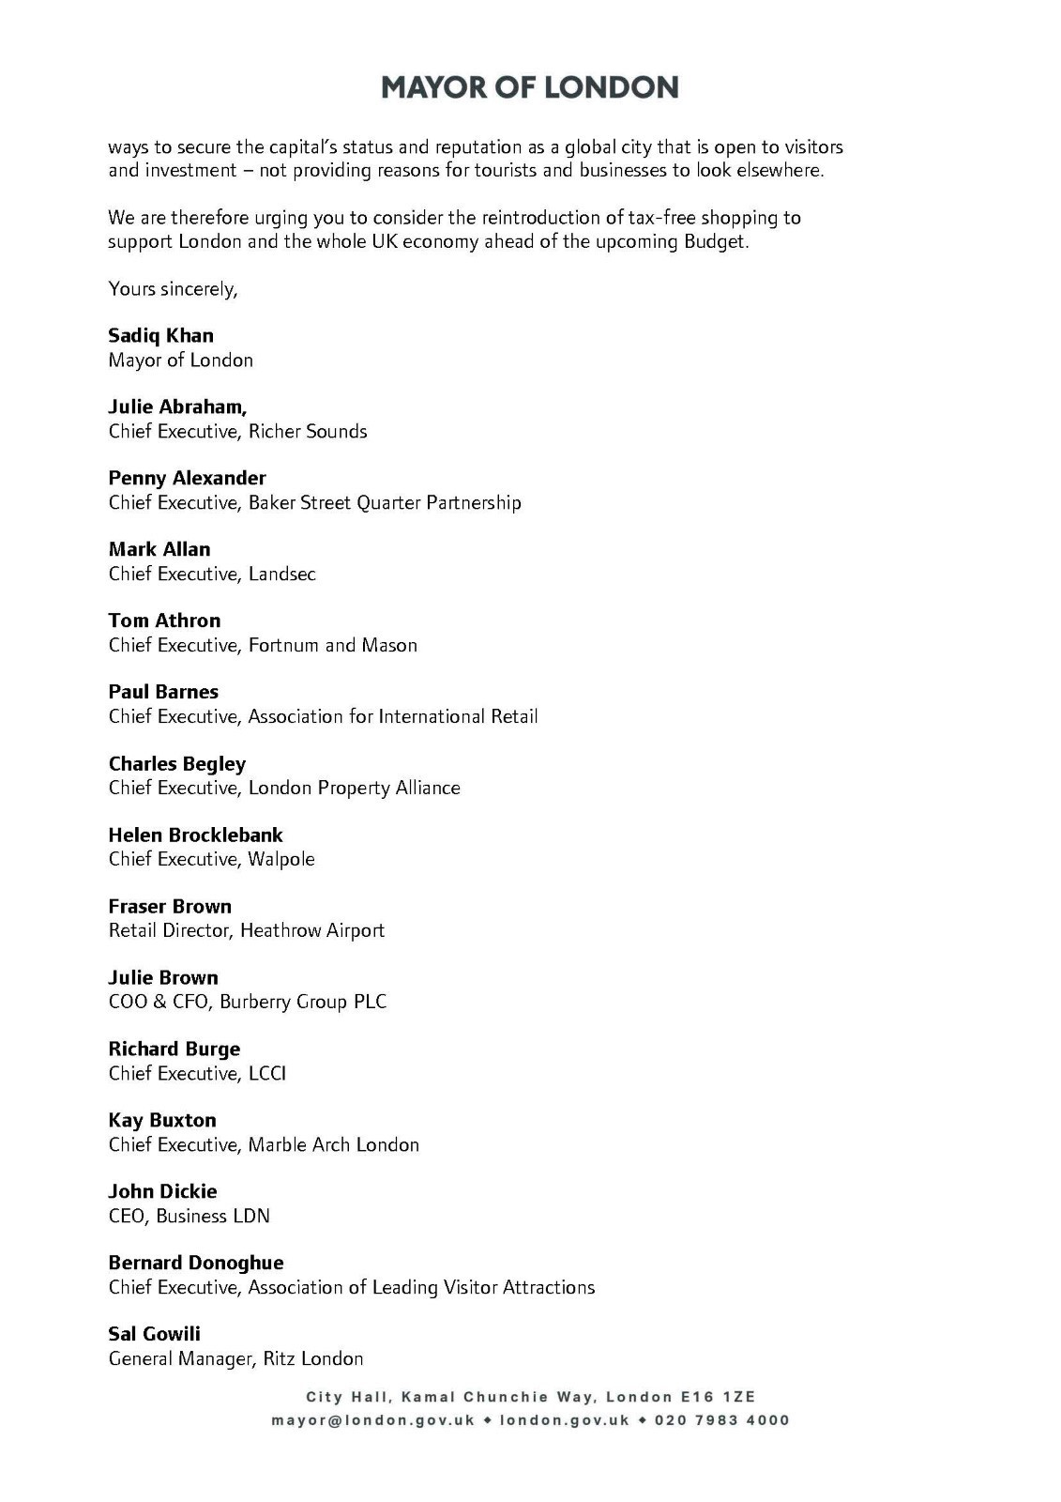
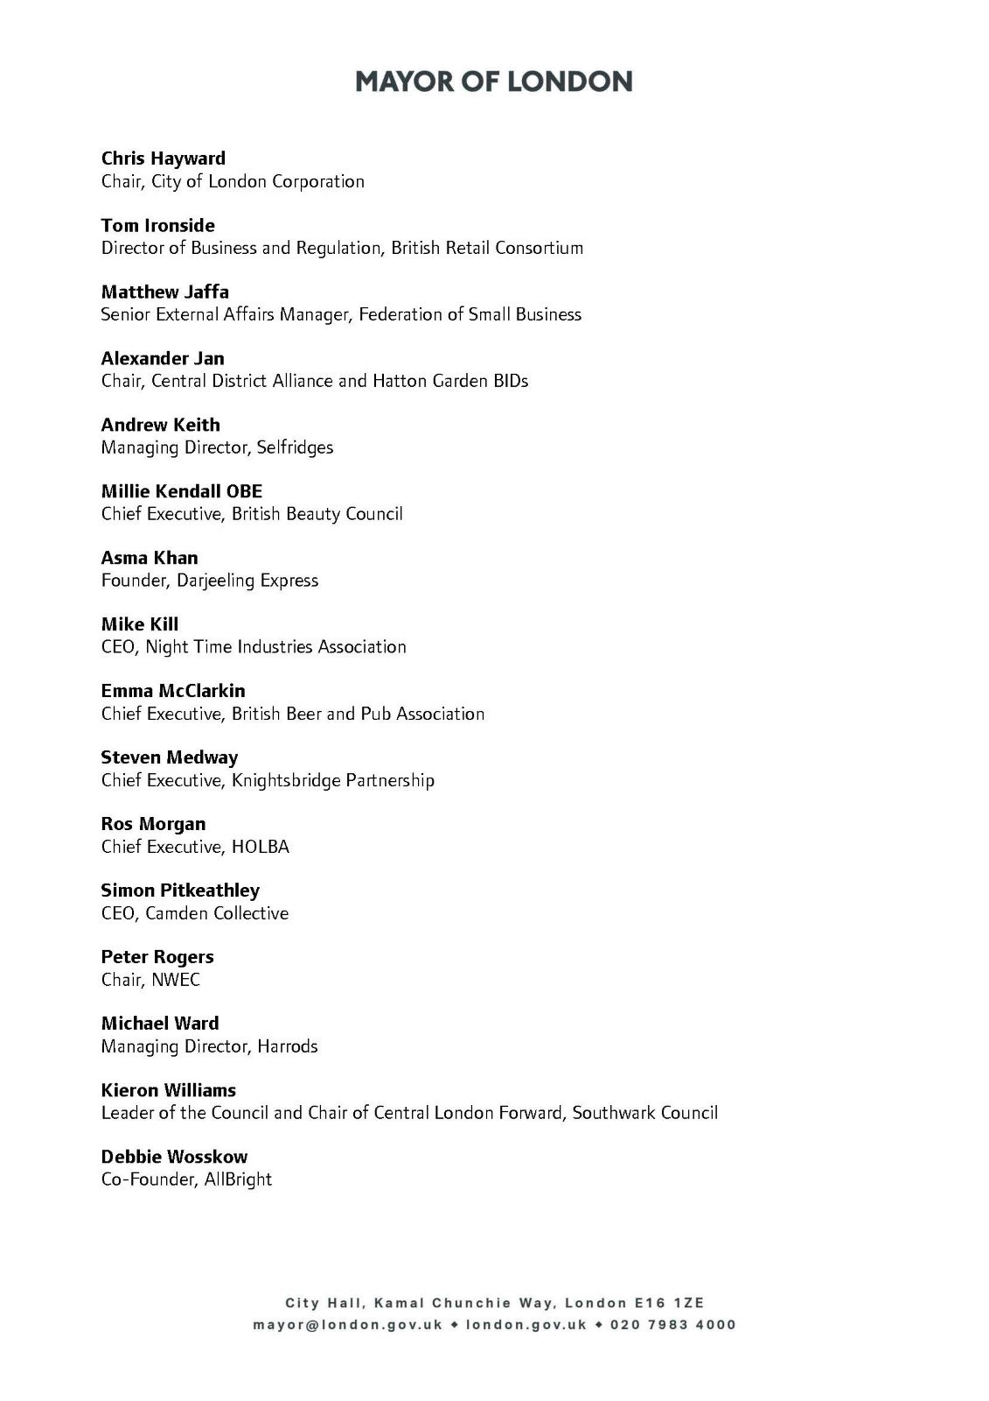

ViistBritain - ibid
CNN travel – The World’s top city destinations for 2022 are revealed – December 2022. Paris was number 1 and Dubai number 2
VisitBritain – “Britain’s visitor economy facts” and “2019 snapshot”
UNWTO Global barometer 2018 records Chinese visitors as the World’s largest travel spenders at $258 billion in 2018 , nearly twice as much as the second biggest spenders (USA at $135 bn)
In 2019 only 9% of Chinese people held a passport. In the UK it is over 70%
VisitBritain - ibid
Department for Business and Trade “UK trade in numbers” February 2023
VisitBritain/ Deloitte “Tourism Jobs and Growth: the economic value of tourism to the UK economy” calculated that the marginal cost of a job in the tourism industry in 2013 was £54,000, or £63,000 in 2020.

